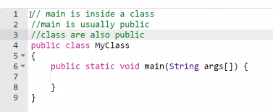

static member is a member of a class that isn't associated with an instance of a class. Instead, **the member belongs to the class itself**. As a result, you can access the static member without first creating a class instance (object).



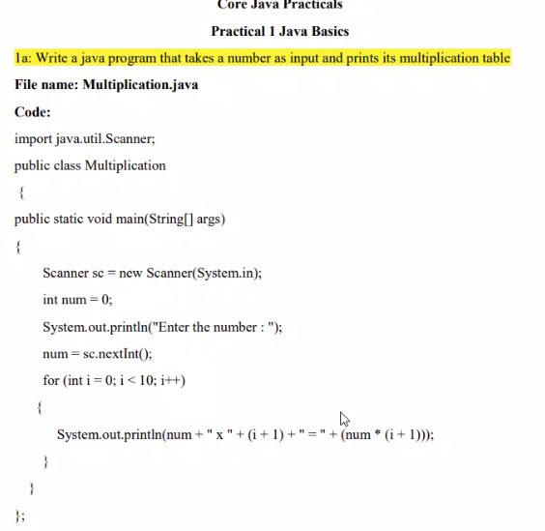

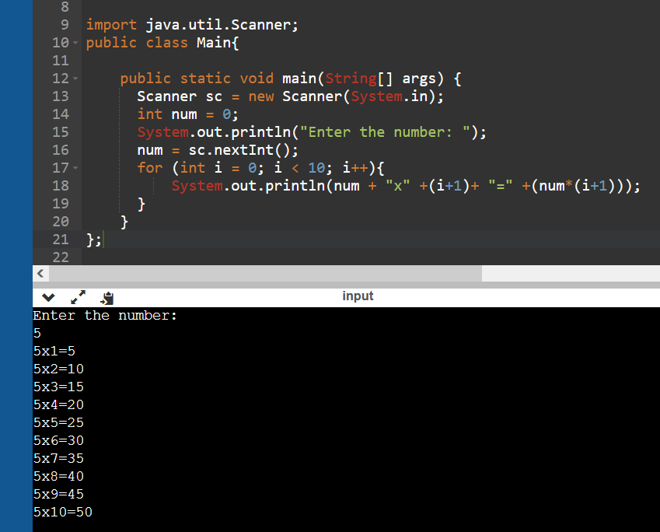

import java.util.Scanner;

public class Main{

public static void main(String[] args) {

Scanner sc = new Scanner(System.in);

int num = 0;

System.out.println("Enter the number: ");

num = sc.nextInt();

for (int i = 0; i < 10; i++){

System.out.println(num + "x" +(i+1)+ "=" +(num*(i+1)));

}

}

};

2. 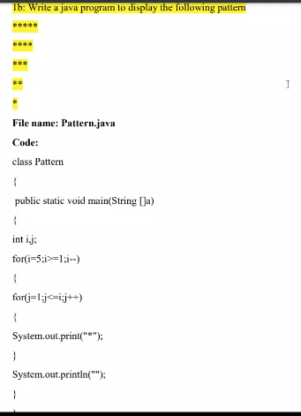

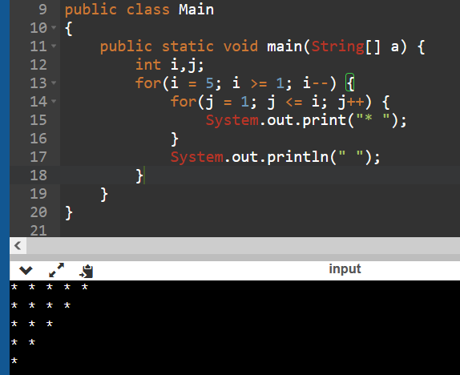

public class Main

{

public static void main(String[] a) {

int i,j;

for(i = 5; i >= 1; i--) {

for(j = 1; j <= i; j++) {

System.out.print("* ");

}

System.out.println(" ");

}

}

}

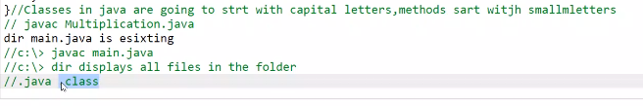



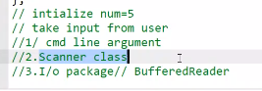

3.

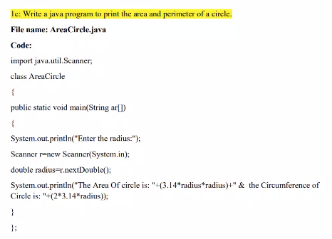

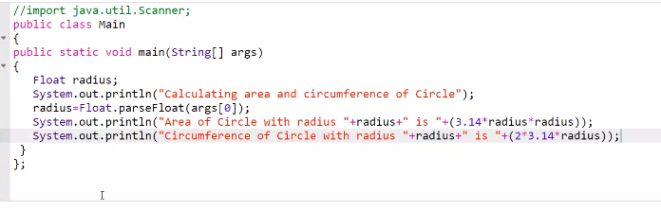

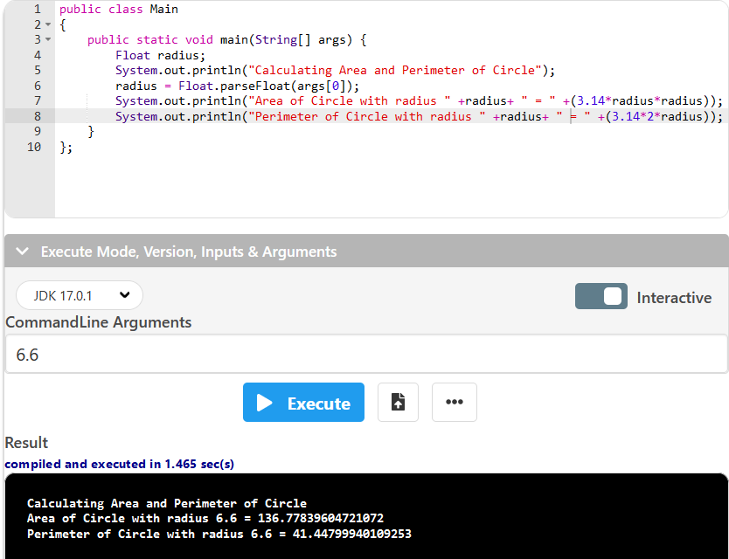

public class Main

{

public static void main(String[] args) {

Float radius;

System.out.println("Calculating Area and Perimeter of Circle");

radius = Float.parseFloat(args[0]);

System.out.println("Area of Circle with radius " +radius+ " = " +(3.14*radius*radius));

System.out.println("Perimeter of Circle with radius " +radius+ " = " +(3.14*2*radius));

}

};

2b.

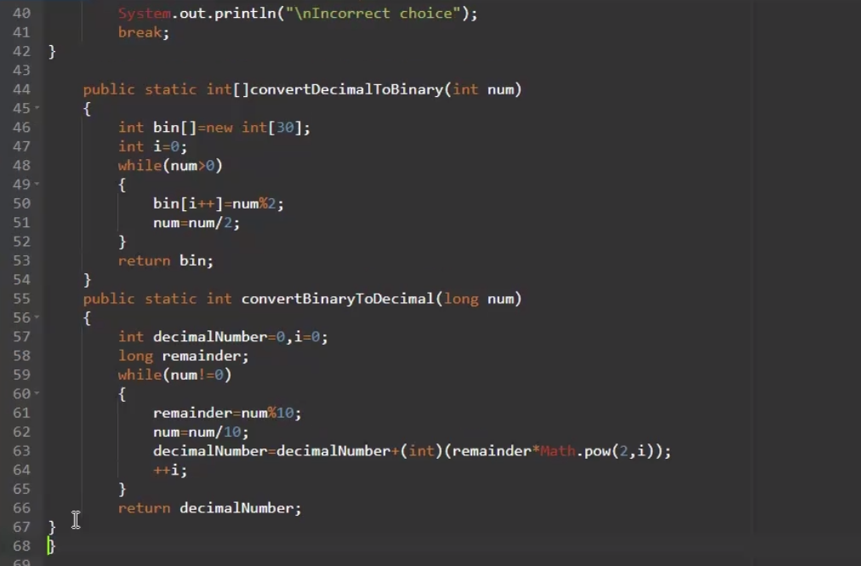

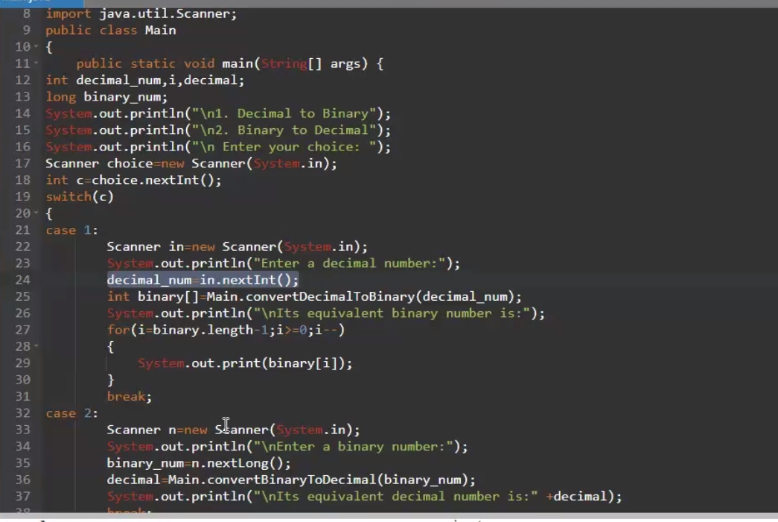

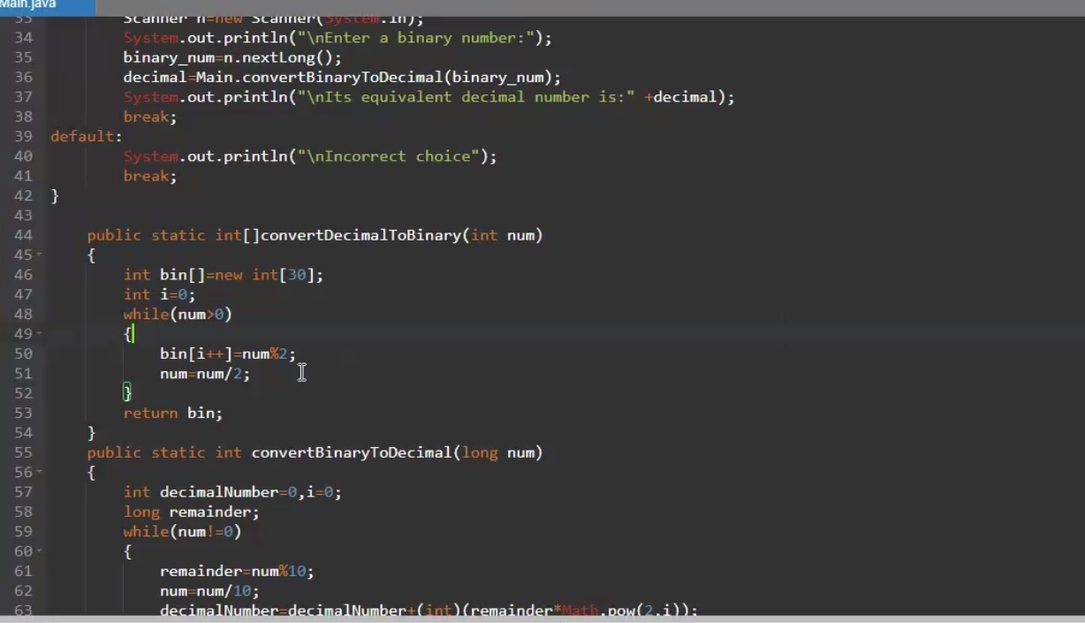

2c.

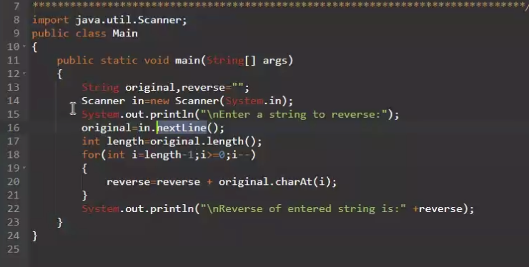

3a.

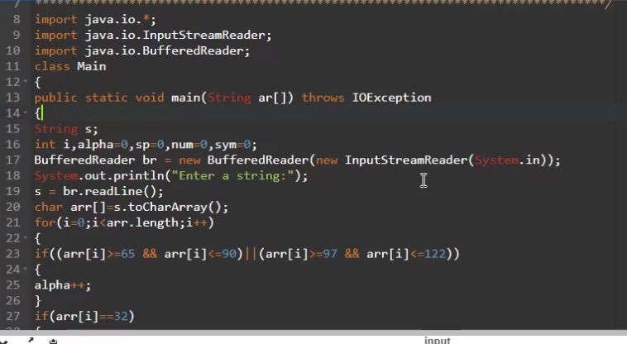

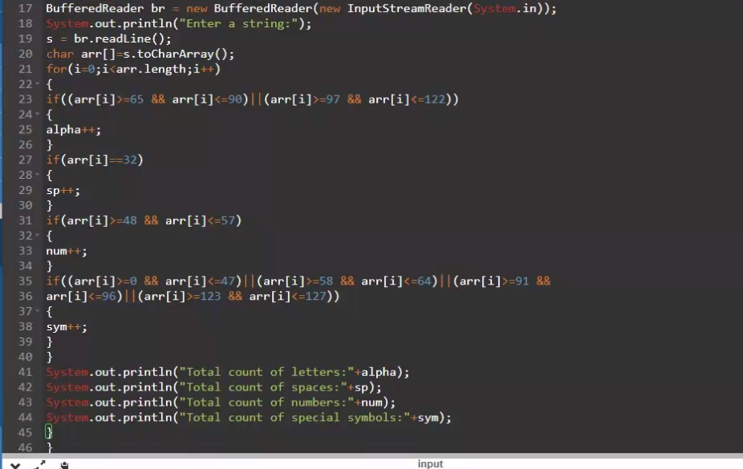

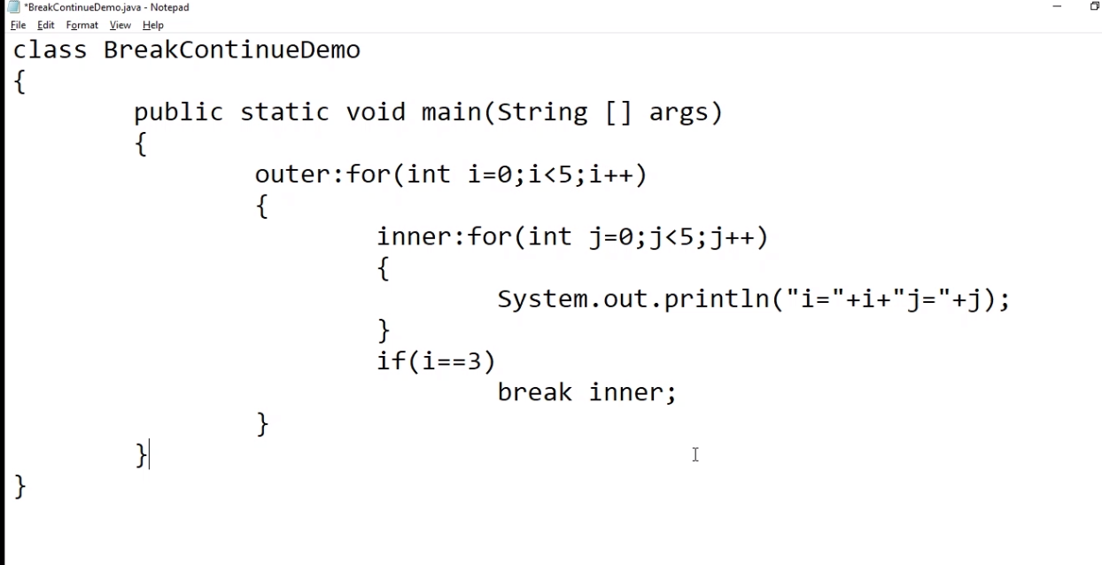

3b.

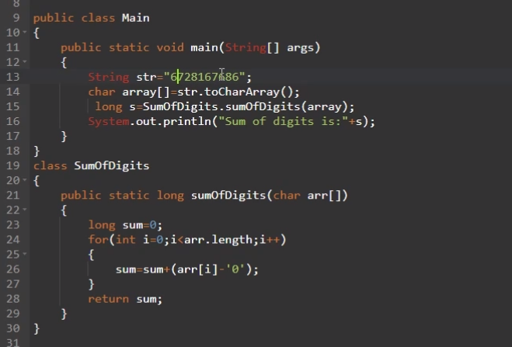

3c.

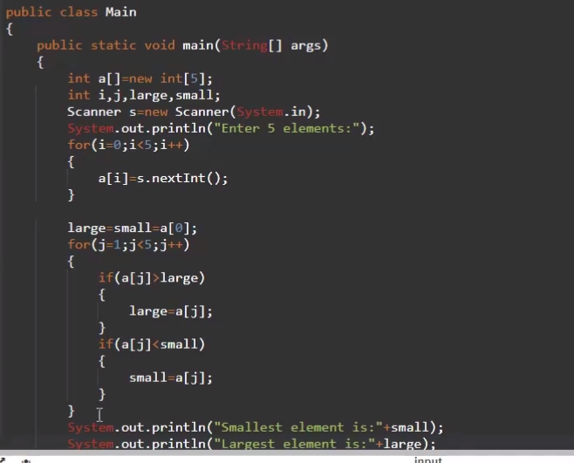

4a.

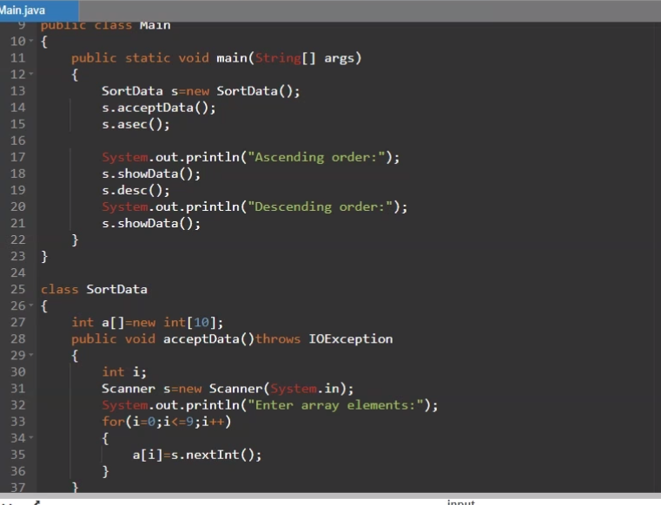

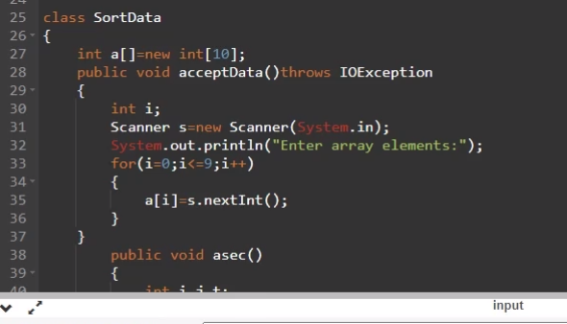

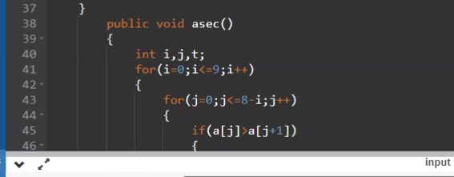

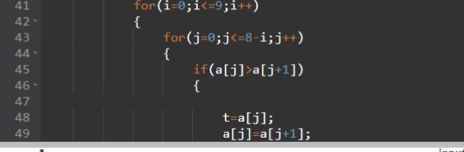



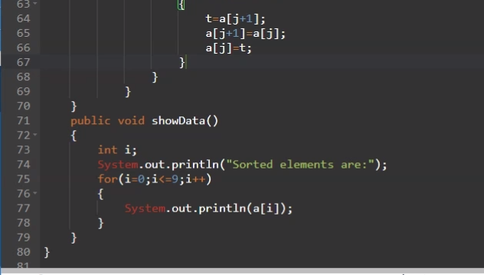

4b.

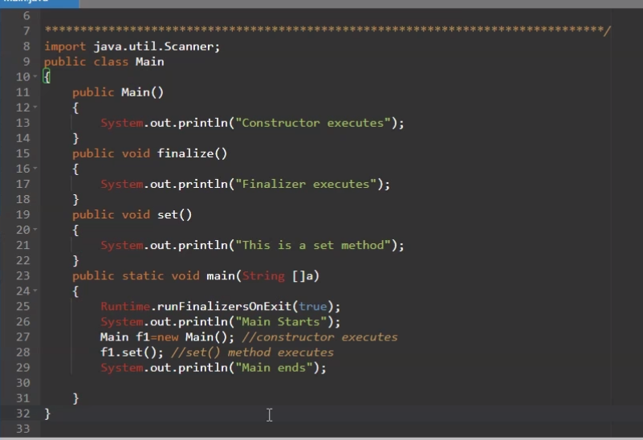

6b

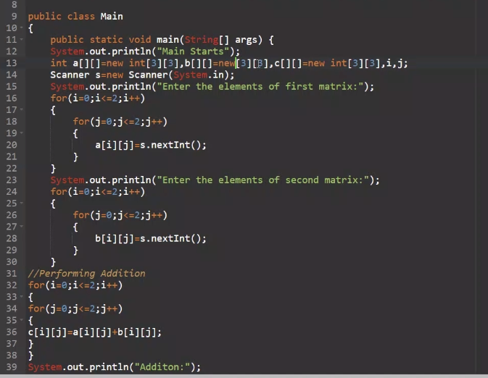

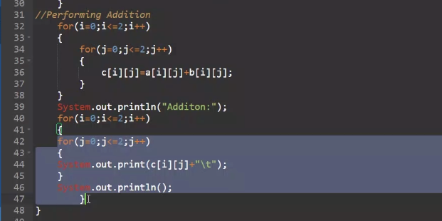

6c

